Dear Sir / Madam

Thank you for your interest in our **Shield Express Car Wash** Brand, please find herewith the relevant information as requested.

Please be advised that there are very limited sites available and we would recommend that **you should look for your** **own premises**. We will assess the site and give our opinion as to the viability of the site. Premises should be in the region of **220 m2**. (including parking) Once we have done a feasibility study and found the premises viable, you will have to do a Personality Profile Analysis in order to determine your appointment as a franchisee for a **Shield Express Car Wash**.

* The complete set-up cost FOR A BRAND-NEW SITE is in the region of **R1650 000** (based on 220m2) **2 bay cleaning station**
* The set-up cost for a **3-bay cleaning station** is in the region of **R1 950 000** based on **240 – 280 m2**
* The set-up cost for a **4-bay cleaning station** is in the region of **R2 450 000** based on **260 – 300 m2**
* **Your own contribution unencumbered is 50% of the above** (This forms part of the setup cost and the balance can be financed by your own financial institution (Bank).
* **We have based the our pricing on the assumption that we do not need to pave the site and the area is a flat level surface (we don’t need to do any landfill)**
* **Please note the above excludes the deposit which may be required by the landlord to secure your site**
* The Once off Setup **Franchise fee is R150 000**; split into 2 deposits –

**R75 000** payable once you are appointed as a Franchisee, this will be utilized for the site visit, and franchise costing. The second **R75 000** is payable once the above drawings are received and we commence with the installation. Once the drawings have been received, they will be put out to our appointed suppliers.

**Excludes the cost of the office container if office space is not provided by the landlord**

**A 50% deposit is required before development of the site. Balance is payable before hand over.**

* **The franchise fee also includes the following: -**
* Franchise Agreement
* 2 Weeks training for staff including the franchisee and manager
* Initial uniforms for the above people (hats; overalls; boots flyers and shirts)
* Royalty of R3207 per month is payable (excl VAT)
* Software fee R449.00 per month is payable (excl VAT)
* **We do have limited trading corporate sites available for sale. These will be sold at a market related price. The cost of these trading sites starts at R1 500 000**
* **Where to look for premises:**
* Shopping Centres or Malls of 10,000m2 and more
* Next to Fuel Stations with an average fuel consumption of 450 000 litres per month.
* Your rental amount should not exceed R75.00 per square meter
* In order to make an investment of R1400 000 work , the franchisee requires1000-1300 customers per month spending on average R100 to R130 per customer to reach the required turnover

**Once you have found a suitable site or would like to discuss an existing site please e-mail the relevant details of the premises to** [**franchise@shieldexpress.co.za**](mailto:franchise@shieldexpress.co.za)**.**

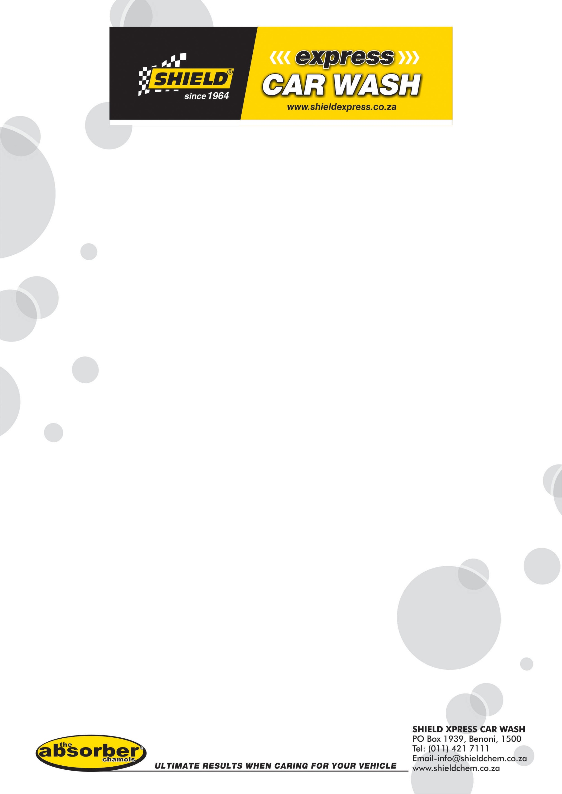**Franchise Team**